**BRANCHES IN GITHUB(LAB03)**

Create a branch with the name being your roll number.

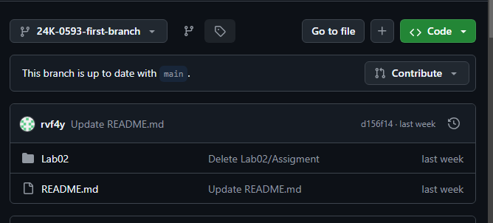

Create a Problem.md file which contains an item list in which an algorithm is defined for finding even and odd numbers.

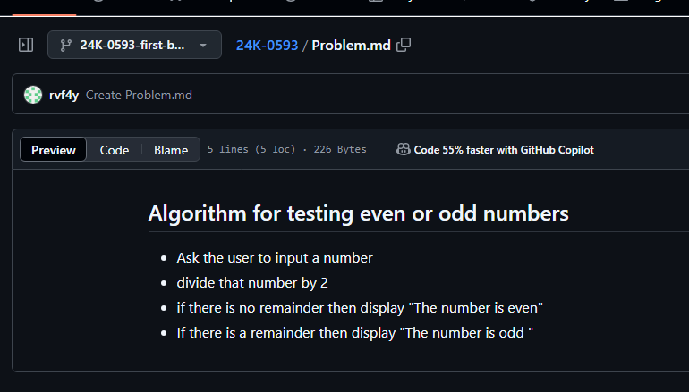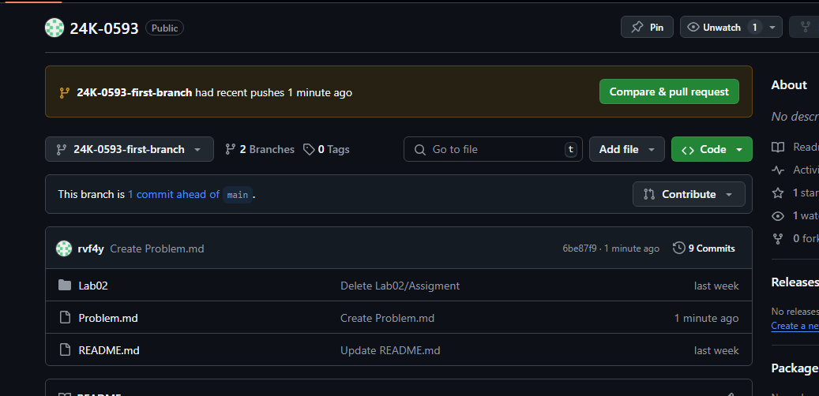

Create a pull request and merge the request as well.